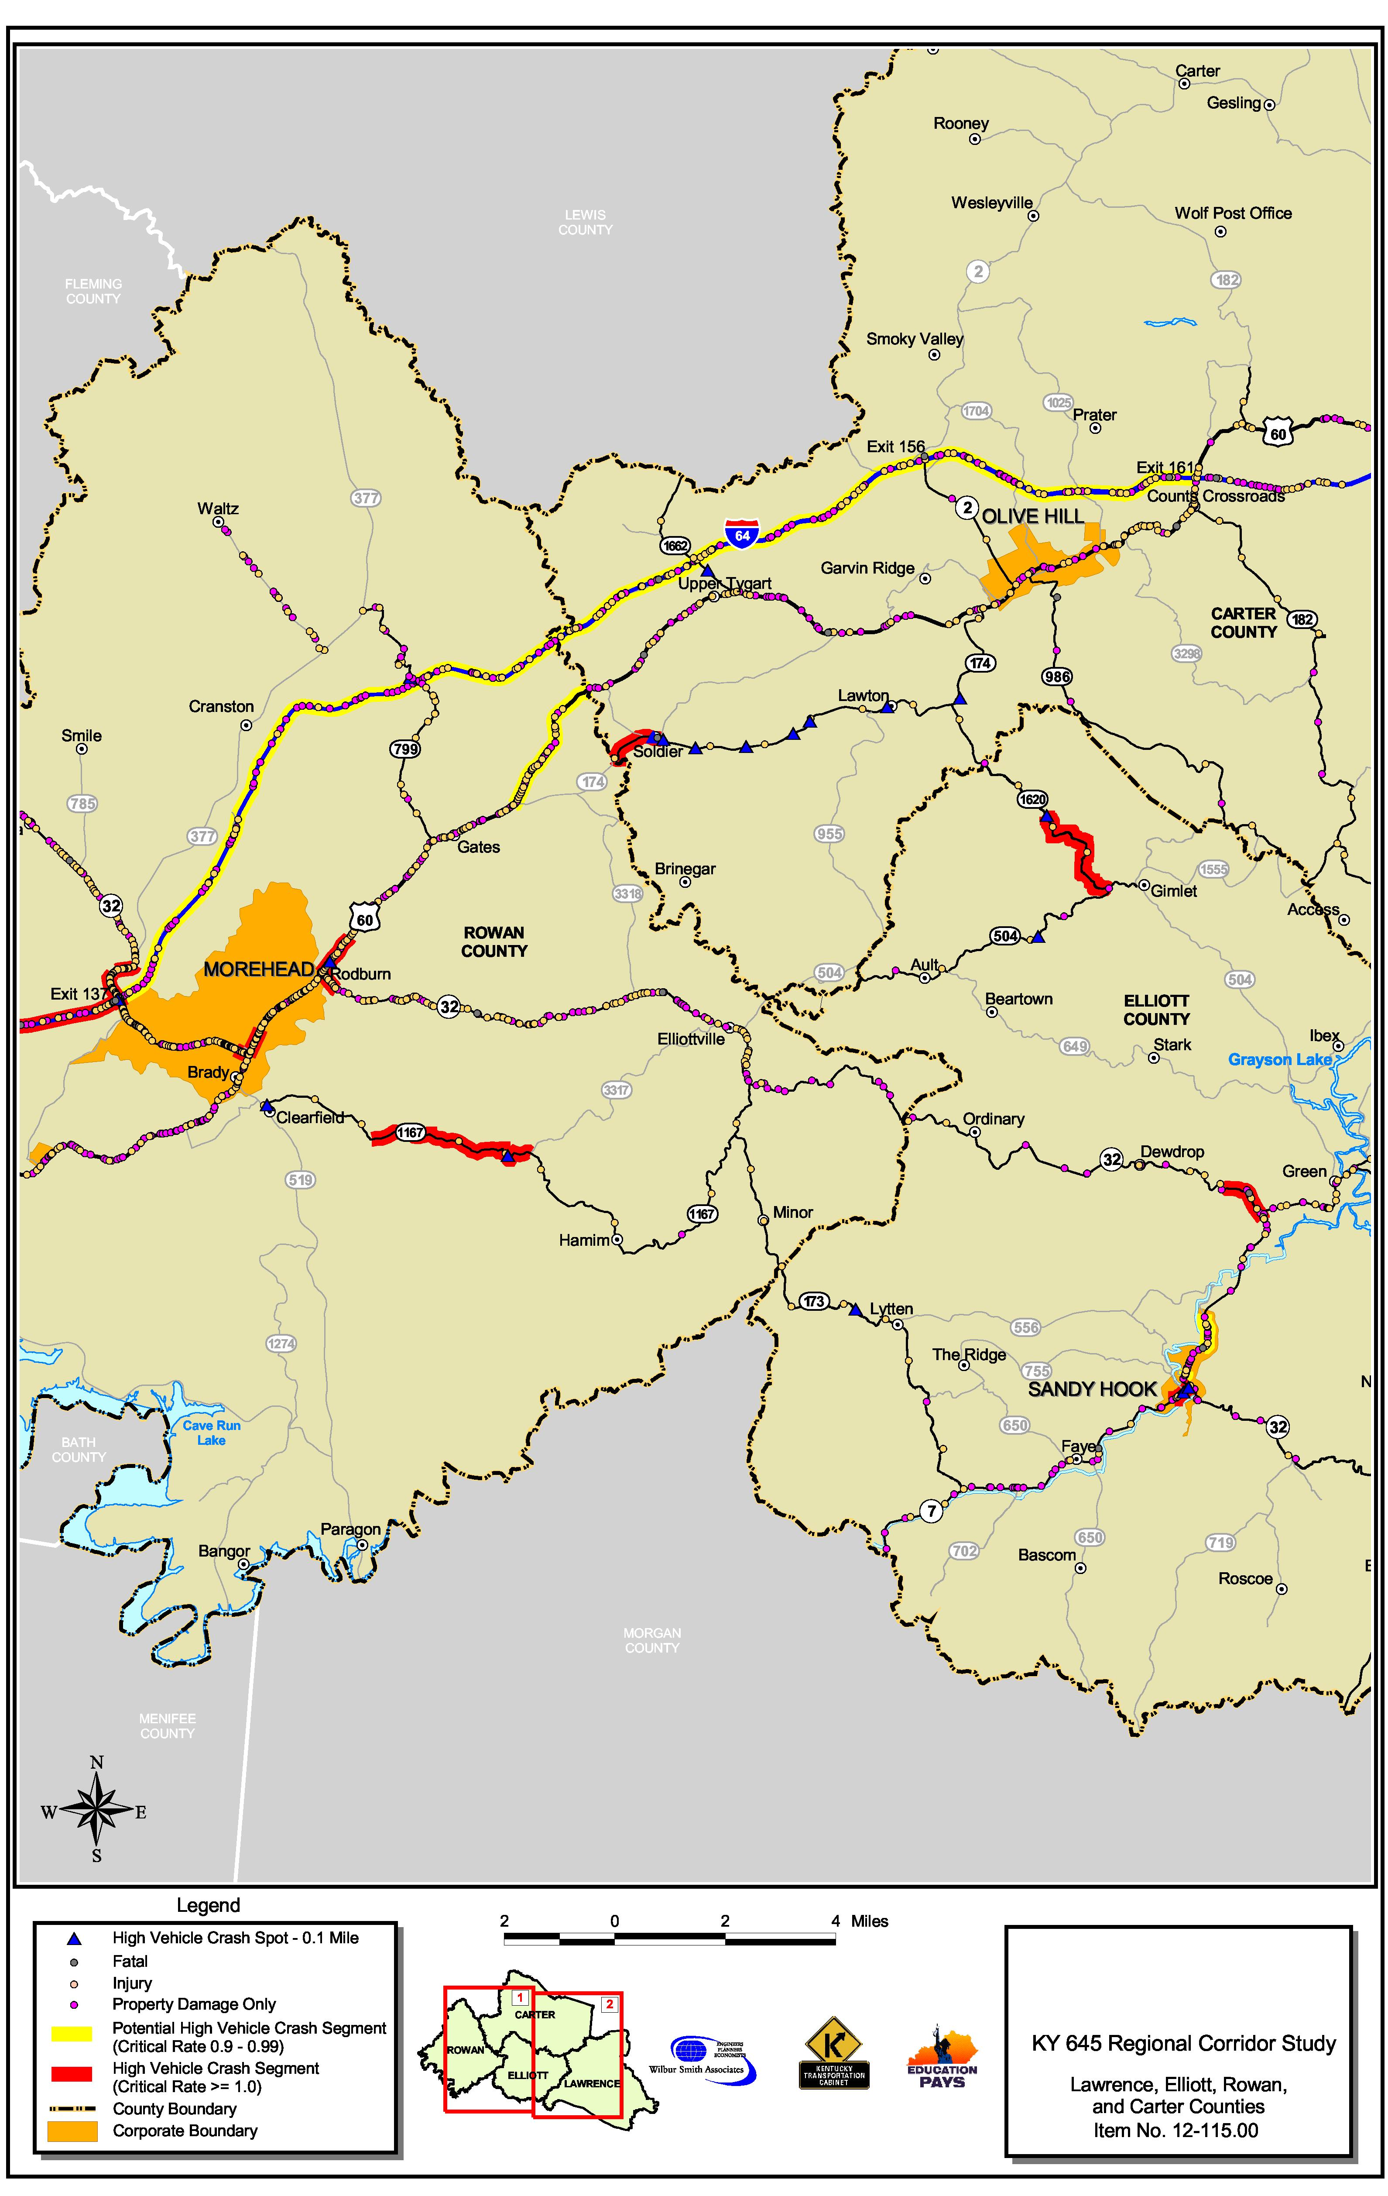

Vehicle Crash Information
Source: Kentucky State Police Database (January 1998 to December 2001).

